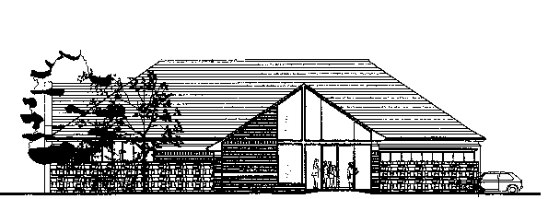

St Leonard‘s Community Centre, Wollaton, Nottingham NG8 2ND

TABLE OF CHARGES from January 2026
For Regular Groups or Charities

 | MAIN HALL  With kitchen | SMALL HALL  With kitchenette | BOTH HALLS | Committee Room  (seats 12)
Monday to Friday  (day time rate) | £15.00 per hour  (minimum of a  2 hour booking) | £11.00 per hour  (minimum of a  2 hour booking) | £24.75 per hour | £10.00 per hour
Monday to Friday  (evening rate) | £29.75 per hour | £23.25 per hour | £50..25 per hour | £13.25 per hour
Saturday  (day time rate) | £17.00  per hour  (minimum of a  3 hour booking) | £12.50 per hour  (minimum of a  3 hour booking) | £27.50 per hour | £12.00 per hour
Saturday  (evening rate) | £49.25 per hour | £34.75 per hour | £77.50 per hour | £18.00 per hour
Sunday | Not available | Not available | Not available | Not available

St Leonard‘s Community Centre, Wollaton, Nottingham NG8 2ND

TABLE OF CHARGES for Ah hoc events from January 2026

 | MAIN HALL  With kitchen | SMALL HALL  With kitchenette | BOTH HALLS | Committee Room  (seats 12)
Monday to Friday  (day time rate) | £22.25 per hour  (minimum of a  2 hour booking) | £15.50 per hour  (minimum of a  2 hour booking) | £35.75 per hour | £12.25 per hour
Monday to Friday  (evening rate) | £54.00 per hour | £39.75 per hour | £89.00 per hour | £18.50 per hour
Saturday  (day time rate) | £25.75 per hour  (minimum of a  3 hour booking) | £18.50 per hour  (minimum of a  3 hour booking) | £42.00 per hour | £15.50 per hour
Saturday  (evening rate) | £67.75 per hour | £49.50 per hour | £111.50 per hour | £24.50 per hour
Sunday | Not available | Not available | Not available | Not available

EXTRAS
Stage - £60 per session
Stage lights £50 per session
Bond £250.00 per session, all evening events, (daytime parties where applicable.)

